Lab 4

Rong Guo

C00290890

Catalog

Download Istio 3

Go to the Istio release page to download the installation file 3

Install Istio 3

Install Istio using the demo profile, without any gateways 3

Install the Kubernetes Gateway API CRDs 3

Install the Gateway API CRDs, if they are not already present 3

Deploy the sample application 4

Deploy the Bookinfo sample application 4

The application will start. As each pod becomes ready, the Istio sidecar will be deployed along with it 4

Validate that the app is running inside the cluster by checking for the page title in the response 4

Open the application to outside traffic 5

Create a Kubernetes Gateway for the Bookinfo application 5

Change the service type to ClusterIP by annotating the gateway 5

To check the status of the gateway, run: 5

Access the application 5

View the dashboard 6

Install Kiali and the other addons and wait for them to be deployed 6

Access the Kiali dashboard. 6

Download Istio

Go to the Istio release page to download the installation file



Move to the Istio package directory and add the istioctl client to the path

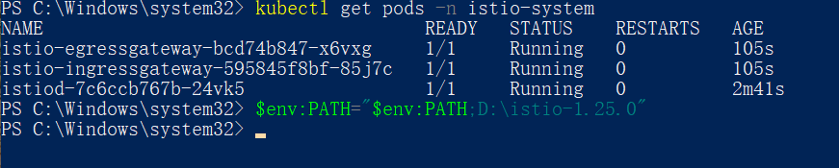

Install Istio

Install Istio using the demo profile, without any gateways

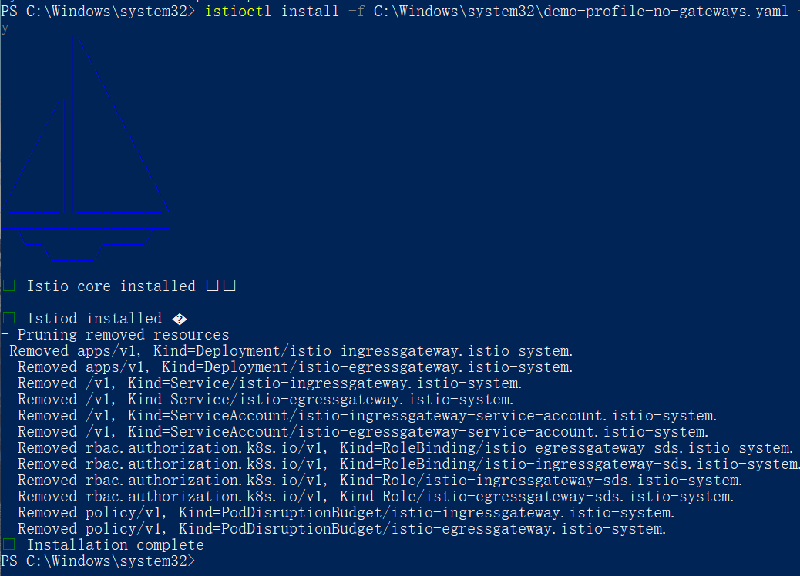

Install the Kubernetes Gateway API CRDs

Install the Gateway API CRDs, if they are not already present

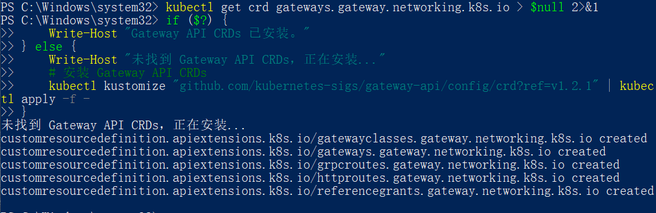

Deploy the sample application

Deploy the Bookinfo sample application

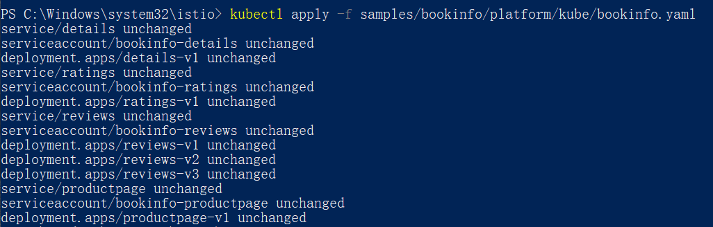

The application will start. As each pod becomes ready, the Istio sidecar will be deployed along with it

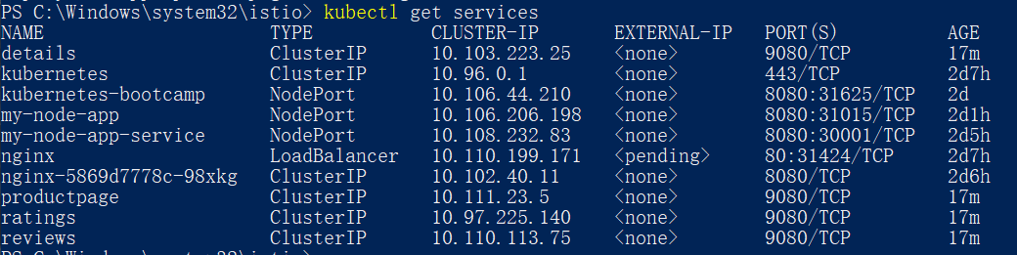

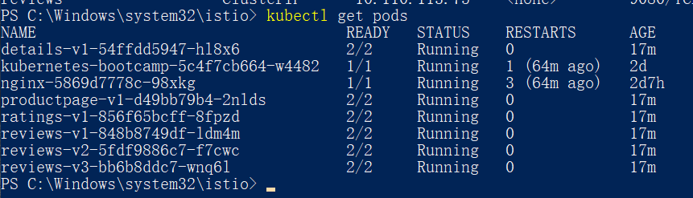

Validate that the app is running inside the cluster by checking for the page title in the response

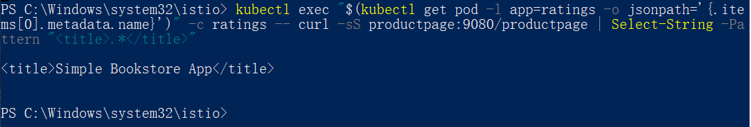

Open the application to outside traffic

Create a Kubernetes Gateway for the Bookinfo application

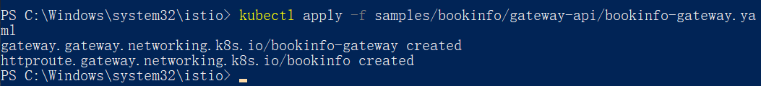

Change the service type to ClusterIP by annotating the gateway



To check the status of the gateway, run:



Access the application

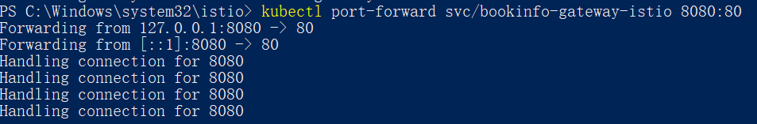



View the dashboard

Install Kiali and the other addons and wait for them to be deployed

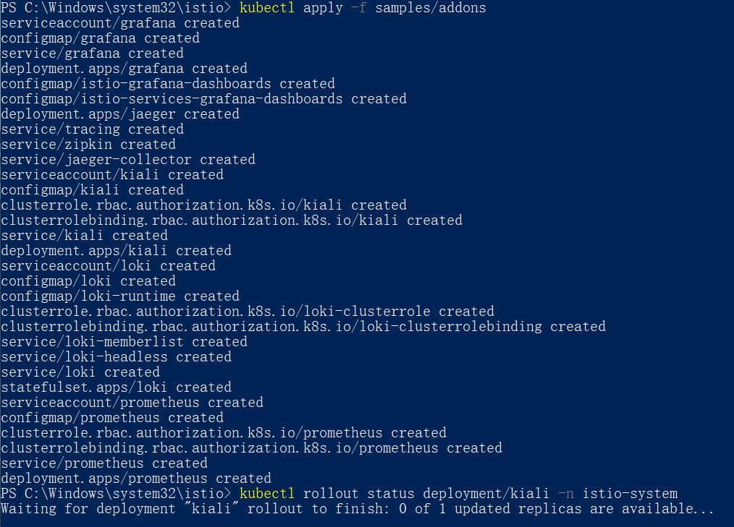

Access the Kiali dashboard.

